| **STREAMANALTIX 3.1.0** | Learn about-**Dynamo DB- -Channel** |

# Custom DynamoDB Channel

Amazon DynamoDB is a fast and flexible NoSQL database service for all applications that need consistent, single-digit millisecond latency at any scale. It is a fully managed cloud database and supports **both document and key-value store models**. Its flexible data model and reliable performance make it a great fit for mobile, web, gaming, ad tech, IoT, and many other applications.

**DynamoDB Configuration**

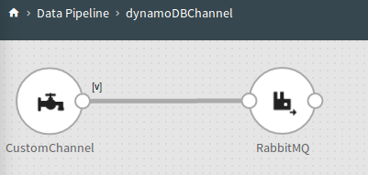

## Configure DynamoDB Channel

**Step 1:** Drag the DynamoDB Chanel on the pipeline canvas and right click on it to configure. On the Select Message tab, select a Message Type and provide a Message Name

|  |  |
| --- | --- |
| **Field** | **Description** |
| **Message Type** | **Single:** If only one message needs to be parsed in the pipeline.  **Multi:** If multiple messages needs to be parsed in the pipeline. |
| **Message Name** | Click on the Message Name input field to get a list of all the messages and select message(s). |
| **Schema Identifier** | In case, you have written your own code for schema identification, check the box to provide fully qualified name of your class. |

**Step 2:** Configure DynamoDB channel properties on the **Configuration** tab.

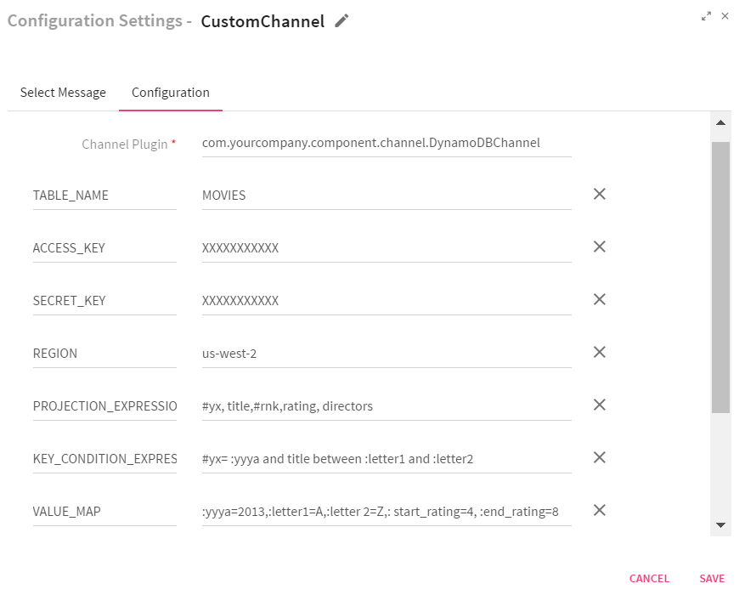

|  |  |
| --- | --- |
| **Field** | **Description** |
| **Channel Plugin** | Fully qualified class name of the channel executor |
| **TABLE_NAME** | DynamoDB table name from which channel will fetch the data |
| **ACCESS_KEY** | Access key of the user over AWS. AWS account is identified by Access Key ID, which AWS uses to look up for your Secret Access Key. |
| **SECRET_KEY** | Secret access keys are—as the name implies—secrets, like your password. For your own security, AWS doesn’t reveal your password to you if you forgot it (you’d have to set a new password). Similarly, AWS does not allow retrieval of a secret access key after its initial creation. This applies to both root secret access keys and AWS Identity and Access Management (IAM) user secret access keys. |
| **REGION** | The AWS region name (Default is us-west-2). |
| **PROJECTION_EXPRESSION** | Column name which you want to select. |
| **KEY_CONDITION_EXPRESSION** | Condition expression over partition key OR sort/range key. This expression cannot be used along with INDEX_NAME |
| **VALUE_MAP** | Values for all values placeholder under any expression |
| **NAME_MAP** | Values for column name placeholder under any expression. |
| **FILTER_EXPRESSION** | Condition expression over non-key columns. |
| **INDEX_NAME** | A name for the index. This expression cannot be used along with **KEY_CONDITION_EXPRESSION.** |

To give us your feedback on your experience with the application and report bugs or problems, mail us at [support@streamanalytix.com](mailto:support@streamanalytix.com)

[support@streamanalytix.com](mailto:support@streamanalytix.com)